Herb Chambers Porsche
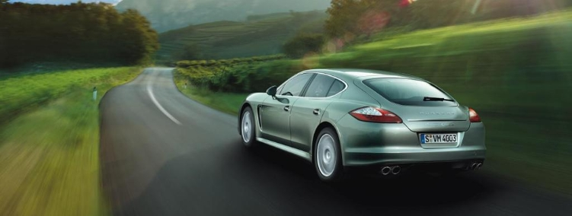
The epitome of Porsche Intelligent Performance has arrived.

You have been cordially invited to Herb Chambers Porsche to get a feel for the new luxurious Porsche Panamera featuring executive class seating and leg room, pure Porsche sport performance and all of the attention to detail we have come to expect from Porsche. You have heard all of the reports, now it is time to see it for yourself.

Join us for a night of food, music and of course, test drives in the all new Panamera! Receive a complimentary gift bag, and event pricing towards your next Porsche.

We look forward to seeing you here!

Date: Wednesday, September 25, 2013
Time: 6 pm – 8 pm
Place: Herb Chambers Porsche
1172 Commonwealth Ave
Boston, MA 02134
RSVP: IMiller@HerbChambers.com

